MathES: Mathematics Equations Solver

David Tran

University of Missouri – Kansas City

https://github.com/davidtstran/CS449-Project
Table of Contents
Vision Statement 3
Requirements 4
Product Backlog 5
Sprint #1 6
Review 6
Retrospective 6
Sprint #2 7
Review 7
Retrospective 7
Sprint #3 8
Review 8
Retrospective 8
Sprint #4 9
Review 9
Retrospective 9
Sprint #5 10
Review 10
Retrospective 10
Sprint #6 11
Review 11
Retrospective 11

Vision Statement
This is where you put the vision for what your program will do. It should summarize key features, explain why this will be useful, and discuss what’s planned for immediate release and what’s envisioned for future development (stretch goals).

MathES: Mathematics Equations Solver:
this Android application would be able to solve any Mathematics equation while showing steps and giving examples. Users can insert any equation to solve, read through steps to solve, and post questions to the online forum for live assistance.

Key Features:
Key features include sections for all levels of Math, including Basic Math, Algebra, Geometry, Algebra II, Pre-Calculus, Calculus I, Calculus II, Linear Algebra, etc. Along with solving equations, the app would include a calculator, a graphing calculator, and a forum where users can post questions for person-to-person assistance.

Usefulness:
This app would be useful because users of any age can use this application to learn all levels of Mathematics.

Planned for Immediate Release:
For immediate release, this application would have sections for around five Mathematics sections, such as Basic Math, Algebra I, Calculus I, Calculus II, Linear Algebra. The basic calculator program should be working and available for use.

Stretch Goals:
For future development, the stretch goals include finishing sections for all available Mathematics sections (and adding more), creating a working graphing calculator, and developing a forum where users can post and reply to questions.

Requirements
A discussion of what your application is required to have in functionality. It should identify user roles and goals/actions, and what the key features of the app should be.
Actor | Goal
Student | Puts in equation to solve, sees the steps to solve
 | Uses built-in calculator and graphing calculator
 | Posts questions in forum
 | Learns various Mathematical courses through examples
Expert | Checks integrity and validity of the equation solver
 | Uses built-in calculator and graphing calculator
 | Answers questions in forum from students

Product Backlog
This will be updated throughout the semester as new PBIs are added, larger items are broken into smaller ones, and completed items removed.

Story ID | Story | Story Points  (in est. hours) | Priority | Status
1 | Create the simple user interface | 10 | L | Sprint 1
2 | Develop Basic Math course section | 3 | M
3 | Develop Algebra course section | 5 | M
4 | Develop Linear Algebra course section | 10 | M
5 | Develop Calculus I course section | 7 | M | Sprint 4
6 | Develop Calculus II course section | 9 | M
7 | Create a working calculator | 5 | L | Sprint 3
8 | Create a working graphing calculator | 15 | S
9 | Set up an online forum where people can post questions and give solutions | 20 | XS
10 | Add multiple various course sections | 40 | S
11 | Clean up the UI, make it advanced | 5 | L
12 | Allow users to customize UI with colors, shapes, font, etc. | 15 | M
13 | Learn the basics of user input using Android | 10 | XL | Sprint 2
14 | Learn the basics of variable usage in Java | 5 | S | Sprint 4

Sprint #1

Sprint Backlog
Story ID | Story / Task | Estimated  Hours | Actual  Hours
1 | Develop the basic UI, buttons, menus, etc. | 8 | 5
1 | Create buttons for various sections | 2 | 2
4 | Start working on the first section (Linear Algebra) | 8 | 2
2 | Develop the Basic Math section | 3 | 0
7 | Work on the built-in calculator function | 5 | 1
13 | Learn the basics of user input using Android | 10 | 10

Review

[Screenshots, etc go here. This is where you discuss the product, describing what was done this sprint (potentially shippable product increment) and what was planned for the sprint but was not done. ]

Sprint 1 Review:

Many planned features were not implemented in this sprint. This sprint mostly involved learning Android in general, including how to implement multiple activities and how to manipulate input from the user. Within this sprint, the basic user interface layout was designed with the buttons that would send the user to the corresponding activities. In each new activity page, it has yet to be filled. Learning how to implement data input has been completed and will be used in the next sprint.

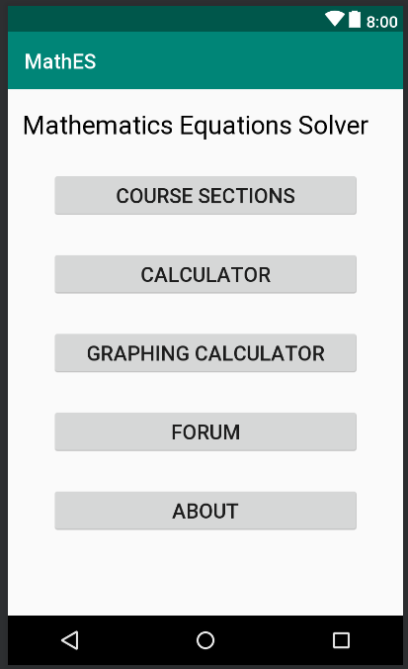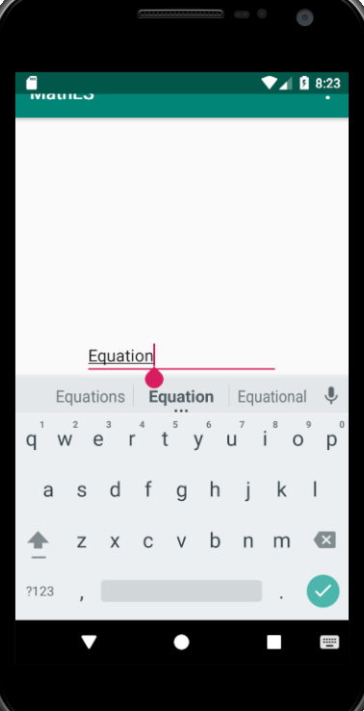

Retrospective
[This is where you discuss the process. What went well (and are you planning to do more of that?) What didn’t go so well (and do you have a way to do less of that)? What changes are you planning to make in how you plan & carry out the next sprint?]
Sprint 1 Retrospective:
During this sprint, I took on more than I could have accomplished. I had to learn the basics of using multiple activities and how to manipulate user input. Implementing the basic buttons and user interface was simple. As I get more time with the project, I will make the interface look cleaner and give the ability for users to customize with colors, fonts, and designs.
In this sprint, I tried to complete some of the sections without knowledge of how to get input in Android Studio. Because of this, I had to put a hold on all my sections because they all require knowledge with user input. The majority of the sprint was then spent trying to handle input.
In the next sprint, I will plan to tackle only a few doable backlog products, such as the calculator and getting one Mathematical section to a deliverable state.

Sprint #2

Sprint Backlog
Story ID | Story / Task | Estimated  Hours | Actual  Hours
7 | Create a working calculator | 5 | 10
13 | Finish understanding how to take user input | 5 | 8
4 | Complete one Math section (LinAlg) | 10 | 5
11 | Clean up the UI, add more buttons and features | 5 | 6

Review

[Screenshots, etc go here. This is where you discuss the product, describing what was done this sprint (potentially shippable product increment) and what was planned for the sprint but was not done. ]

Sprint 2 Review:

For this sprint, I decided to focus mainly on fully learning how to deal with user interaction, such as getting input and displaying output, and creating a functioning calculator program so there would be one usable function for my application.

I have completed understanding how to use input, so now I can take in equations and print out equations using EditText and TextView. The user can now input an equation that they would like to be solved and pressing “Done” would display that function and its solution. The calculator function can create an equation using Buttons that append various characters to a string equation. To develop the buttons within the calculator, a lot of constraining had to be done so that all the buttons can stay in their precise location. If any of the buttons overlapped each other, then the output function could be slightly altered.

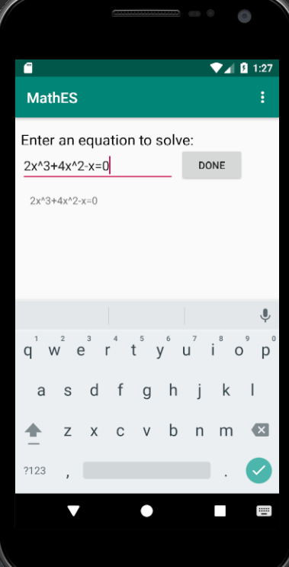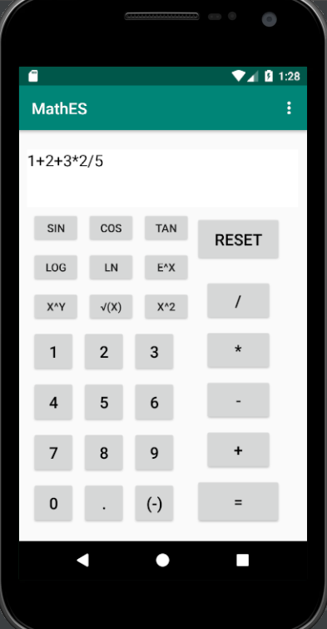

Retrospective
[This is where you discuss the process. What went well (and are you planning to do more of that?) What didn’t go so well (and do you have a way to do less of that)? What changes are you planning to make in how you plan & carry out the next sprint?]

Sprint 2 Retrospective:
Lots of activities would have to be created to develop each “course” section. I have decided to try to focus on only one course section per sprint. There is still a lot to do for the Linear Algebra portion, which is solving for the RREF, Determinant, etc. Getting the data for each matrix would be the first step, then I would have to decide how to output the steps.
For the calculator and equation input/output, I am now able to get user input and display their inputted data. However, I must now figure out a way to solve the data and output in a correct format. This requires me to know learn how to convert a string equation to a combination of string operations and integer numbers to solve.

Sprint #3

Sprint Backlog
Story ID | Story / Task | Estimated  Hours | Actual  Hours
7 | Finish making the working calculator | 10 | 15
4 | Get input for various matrixes in the Linear Algebra section | 8 | 0
11 | Clean up UI | 5 | 7
5 | Begin making the section for Calculus (Derivative/Integrals) | 3 | 0

Review

[Screenshots, etc go here. This is where you discuss the product, describing what was done this sprint (potentially shippable product increment) and what was planned for the sprint but was not done. ]

Sprint 3 Review:

Most of this sprint was to get one fully functioning portion within the application. The portion of choice was the one that would utilize the most out of Android Studio, which is the Calculator function.

Within the Calculator function, there is a string that contains the equation to be solved. Every time a certain button is pressed, it concatenates that value/operator/trig expression to the equation string. Once the ‘=’ button is pressed, then the stored equation would be solved and then displayed.

Overall, the majority of this sprint was spent working on cleaning up the UI by making updates to the buttons, texts, etc.

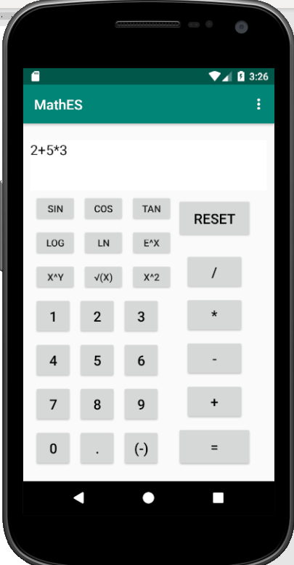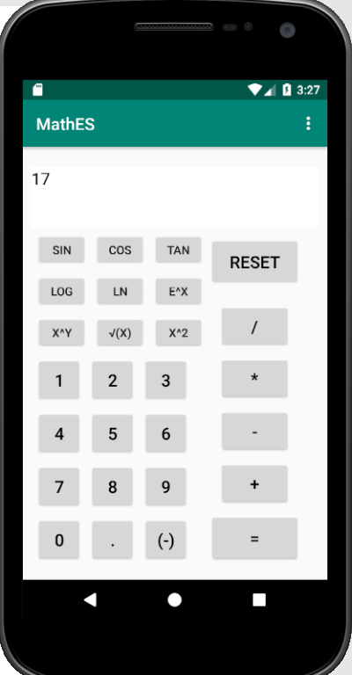

Retrospective
[This is where you discuss the process. What went well (and are you planning to do more of that?) What didn’t go so well (and do you have a way to do less of that)? What changes are you planning to make in how you plan & carry out the next sprint?]

Sprint 3 Retrospective:

For this sprint, I was distracted with other projects that I was not able to complete everything that I had planned to complete.

The Calculator currently does not detect any syntax errors, so if the equation is unsolvable, then the = function would not print out the correct solution. Also, the Calculator does not correctly utilize PEMDAS formulation steps. These errors will be corrected in future updates.

Sprint #4

Sprint Backlog
Story ID | Story / Task | Estimated  Hours | Actual  Hours
4 | Finish Linear Algebra Section | 5 | 0
5 | Finish Calculus Section with Derivative & Integral | (20 total) | (20 total)
 | Derivative Section | 10 | 15
 | Integral Section | 10 | 10
14 | Learn String/Integer/Double functionality using  Java (such as parsing and converting) | 5

Review

[Screenshots, etc go here. This is where you discuss the product, describing what was done this sprint (potentially shippable product increment) and what was planned for the sprint but was not done. ]

Sprint 4 Review:

This sprint finally lead to a “finalized” form for one of the proposed sections. Within the Calculus 1, the Derivative and Integral function works for basic polynomials that only involve integer constants and integer exponents. For the first half of this sprint, I had to familiarize myself with some Java basics; such as string parsing, converting string to integer/double, and converting integer/double to string.

In the Calculus 1 section, the user can now select “Derivative” or “Integral” after inputting an equation to get the respective form that the user has requested. The system parses out the constant and the exponent of the variable then converts the base equation into the desired form. To get the derivative, the constant is multiplied by the exponent and then the exponent is reduced by 1. To get the integral, the constant is divided by (1 + the exponent) and then the exponent is increased by 1.

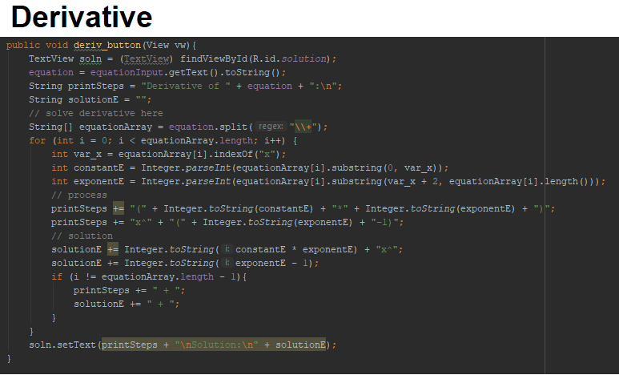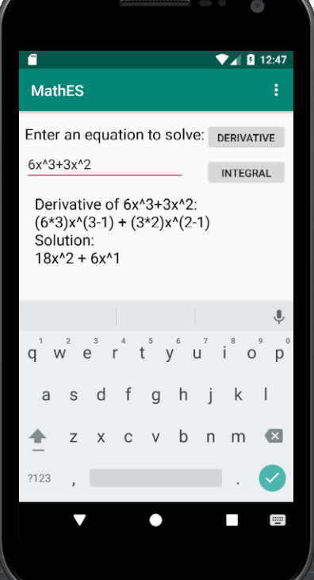

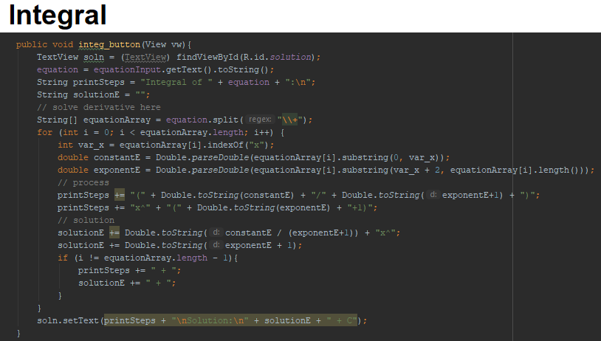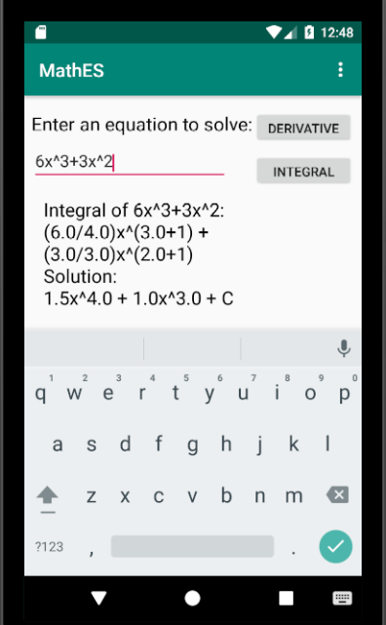

Retrospective
[This is where you discuss the process. What went well (and are you planning to do more of that?) What didn’t go so well (and do you have a way to do less of that)? What changes are you planning to make in how you plan & carry out the next sprint?]

Sprint 4 Retrospective:

For the future, I would finish up the differentiating and integrating by adding full components which would include e^x, trig functions, etc. I also plan to add error check in case the user does not add a valid expression to solve.

Sprint #5

Sprint Backlog
Story ID | Story / Task | Estimated  Hours | Actual  Hours
4 | Linear Algebra Matrix Functionality | (15 total) | 0
 | Solve for RREF | 10 | 0
 | Solve for Determinant | 5 | 0
4 | Creating the Matrix Input Interface | 15 | 0
11 | Cleaned up the UI  Added addition buttons to menu | 15 | 12

Review

[Screenshots, etc go here. This is where you discuss the product, describing what was done this sprint (potentially shippable product increment) and what was planned for the sprint but was not done. ]

Sprint 5 Review:

This sprint was focused on updating the UI to match all the added functionalities. The color of the background and buttons are now more coherent and add a certain theme. The drop down menu has the added buttons that would go to the newly created pages of “Course Sections” and “Calculator”. Code-wise, it was simple to implement these changes.

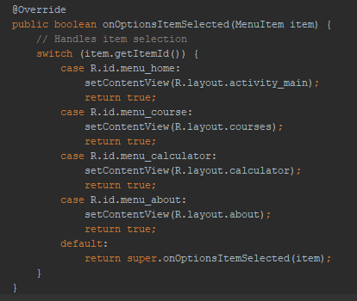

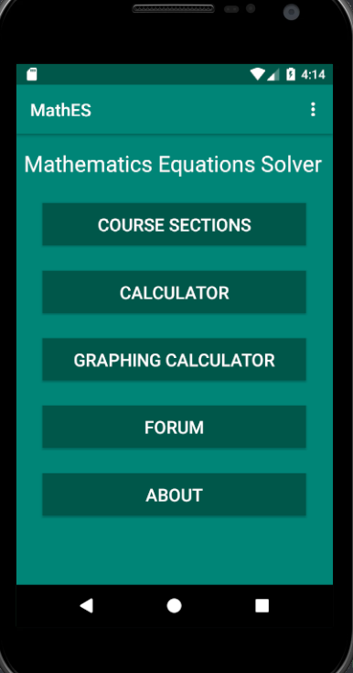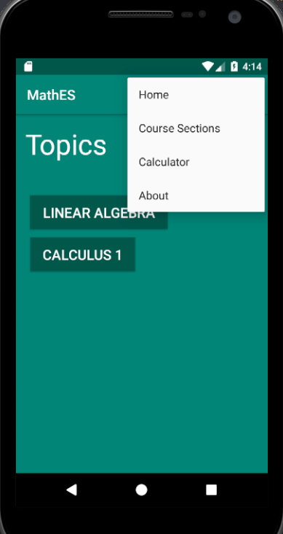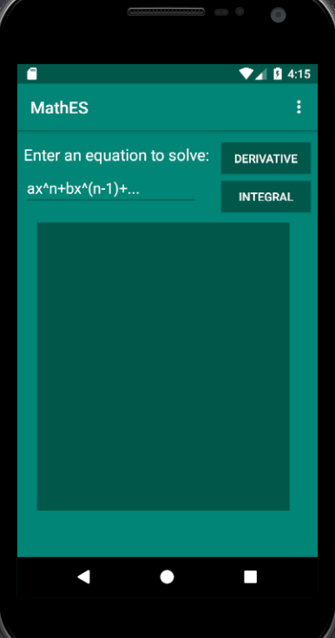

Retrospective
[This is where you discuss the process. What went well (and are you planning to do more of that?) What didn’t go so well (and do you have a way to do less of that)? What changes are you planning to make in how you plan & carry out the next sprint?]

Sprint 5 Retrospective:

This sprint should have had more actual functionalities created. I am currently at a standstill where I do not know how to proceed (because I do not know how to implement what I want to). This sprint was entirely spent on trying to make the UI look better visually for the users. I am trying to implement a certain functionality for the “Linear Algebra” section, but I have troubles trying to implement storing input for a full matrix.

For the future scope, the menu would be added with all the newly created pages. Also there should be a setting where the user can choose various themes that would change background, text, and button colors. The user can instead create custom themes.

Sprint #6

Sprint Backlog
Story ID | Story / Task | Estimated  Hours | Actual  Hours
11 | Clean Up the UI | 5
12 | Make Customizations to UI | 10
2 | Create the Basic Math Section | 10
~ | Plan for Future Iterations | ∞

Review

[Screenshots, etc go here. This is where you discuss the product, describing what was done this sprint (potentially shippable product increment) and what was planned for the sprint but was not done. ]

Sprint 6 Review:

Retrospective
[This is where you discuss the process. What went well (and are you planning to do more of that?) What didn’t go so well (and do you have a way to do less of that)? What changes are you planning to make in how you plan & carry out the next sprint?]

Sprint 6 Retrospective:

